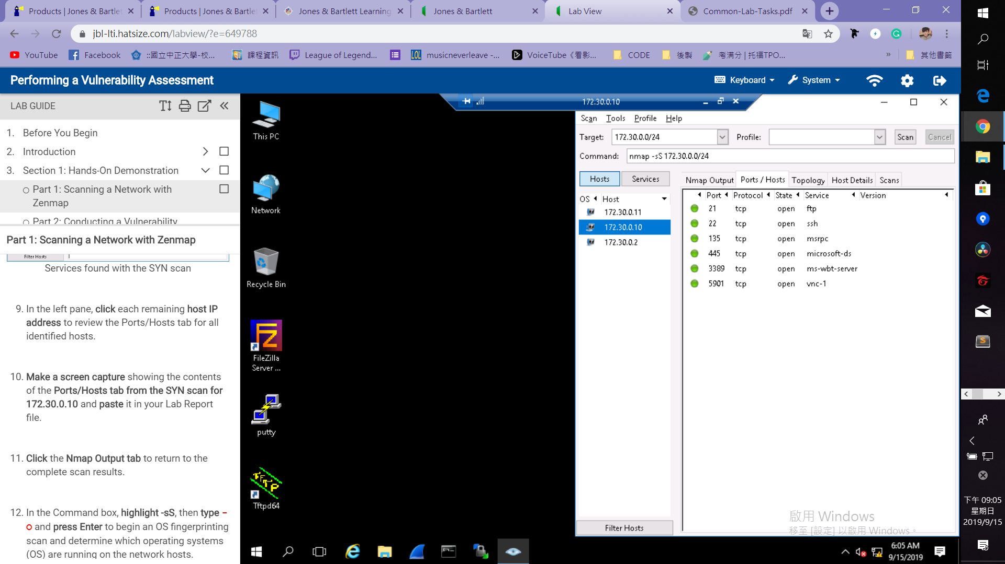 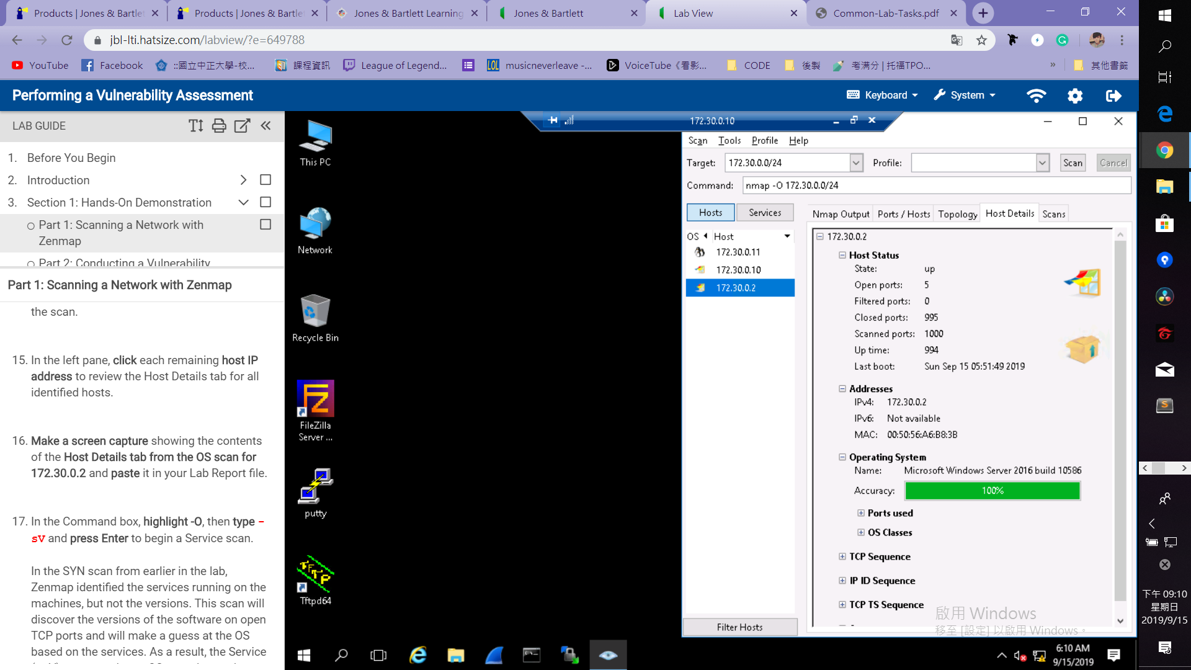 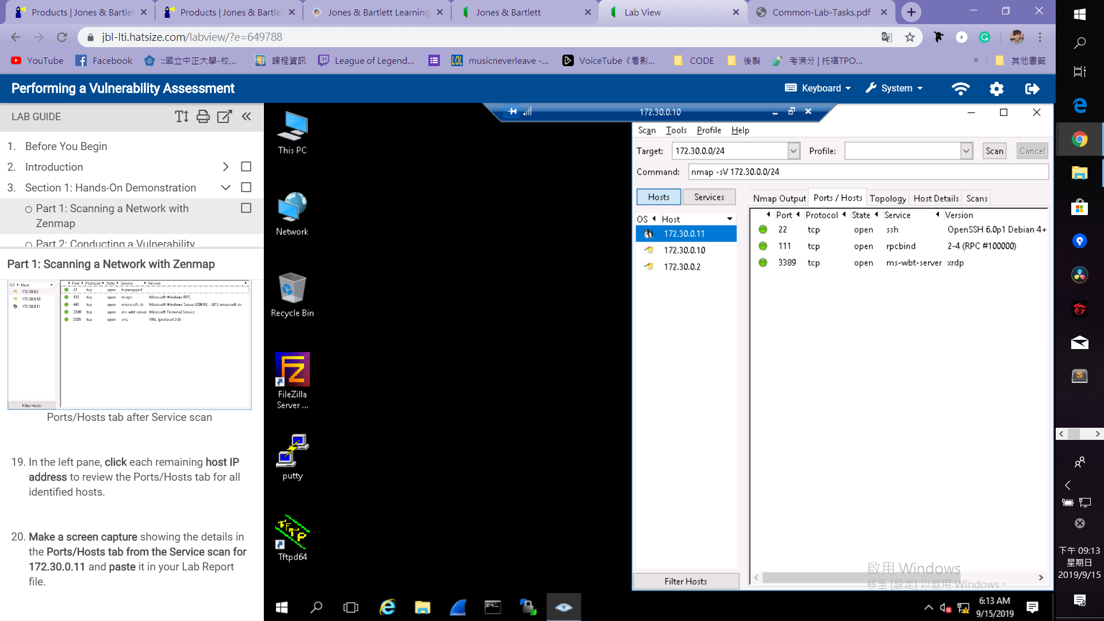

2. Comparision between Zenmap scan with the HTML version of the scan results

All the datas are same.However, HTML version of scan results have less informations than Zenmap scans but more clearly result in just one page.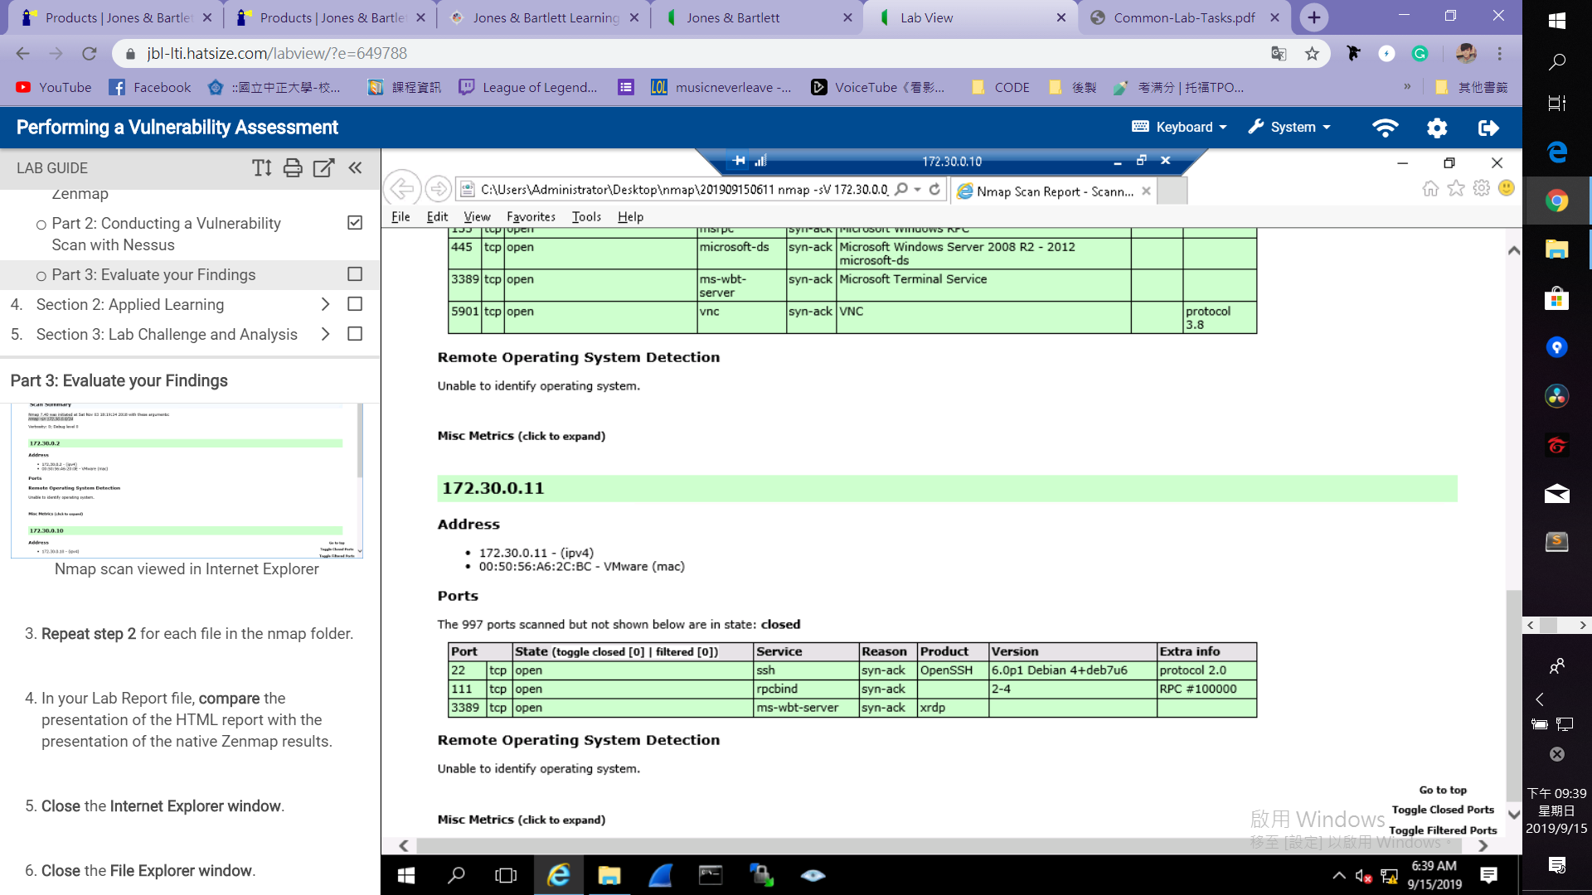

**Medium-risk vulnerabilities found on 172.30.0.10**

Medium (6.4) Id: 51192 SSL Certificate Cannot Be Trusted.

Recommendations: using a certificate for this service.

Medium (6.4) Id: 57582 SSL Self-Signed Certificate.

Recommendations: generate a certificate for this service.

Medium (5.1) Id: 18405 Microsoft Windows Remote Desktop Protocol Server Man-in-the-Middle Weakness.

Recommendations: Using SSL as transport layer for RDP.

Medium (5.0) Id: 57608 SMB Signing Disabled.

Recommendations: On Windows, setting 'Microsoft network server: Digitally sign communications (always)'.

Medium (4.3) Id: 42873 SSL Medium Strength Cipher Suites Supported.

Recommendations: Medium strength is defined within Nessus as any cipher that is between 64-bit and 112-bit or is 3DES. Reconfigure the affected application if possible to avoid use of medium strength ciphers.

Medium (4.3) Id: 57690 Terminal Services Encryption Level is Medium or Low.

Recommendations: Change RDP encryption level to high or FIPS Compliant.